Prepared by the
Inter-American Institute for Cooperation on Agriculture (IICA) Jamaica
Submitted to the Inter-American Development Bank(IDB) Barbados
November 9, 2021

Castor Cropping Calendar-Jamaica Grow Castor Bean Cluster Project - Agronomy Skills Project Inter-American Development Bank Contract#: C-C-JA-T1167-P006
Table of Contents
1. Introduction 2
2. Centre of Origin, Current Distribution and Market 2
3. Soil preparation 3
4. Nutrition or Fertilization 5
5. Planting 11
6. Seed Selection 13
7. Thinning and seed/seedling spacing 14
8. Castor Growth Stages 15
9. Harvesting 17
9.1 When to harvest 17
ANNEX 21
Annex 1: BRS ENERGIA DATA SHEET 21

1. Introduction
Castor (Ricinus communis L.) is a member of the Euphorbiaceae or Spurge family that is found across all the tropical and semi-tropical regions of the world.The seed can contain up to 50% oil content which has a unique fatty acid composition (high in ricinoleic acid) and lubricity which has been used for many years as a pharmaceutical and industrial oil. The seed also contains the highly toxic water-soluble protein — ricin. However, appropriate processing and handling allows the safe production of castor oil and the use of the residual meal from the seed.

2. Centre of Origin, Current Distribution and Market
Castor was initially believed to have four centers of origin: East Africa (Ethiopia), Northwest and Southwest Asia and Arabian Peninsula, India, and China. However, Ethiopia is the most probable site of origin because of the presence of high genetic diversity for this species.
Currently, castor is present either cultivated or growing wild throughout the drier tropical, warm-temperate and subtropical regions between the latitudes of 40° South and 40° North. Castor is found at altitudes from sea level to 2,300 m. As such the castor plant grows under various moisture and soil conditions.
However, growth in world consumption of castor oil is limited by the capacity to produce castoras a crop rather than by the capacity of the industry to use the products (Severino et al., 2012). Further, the price of castor oil is to some extent influenced by the price of other vegetable oils. The average price of castor oil was 66% higher than soybean oil from 2003 to 2011. In that period, the difference between castor and soybean oil prices was the greatest in September 1999 (214%) and smallest in February 2009 (7%). Castor oil prices fluctuated from a minimum of 650 US$/ton in February 2002 to a maximum of 2,700 US$/ton in February 2011 (Severino et al., 2012).

3. Soil preparation

Castor grows and produces well in various types of soil, but its roots require good aeration. Development is stunted in heavy clay soils, or soils lacking appropriate drainage, prone to water-logging, or compacted.
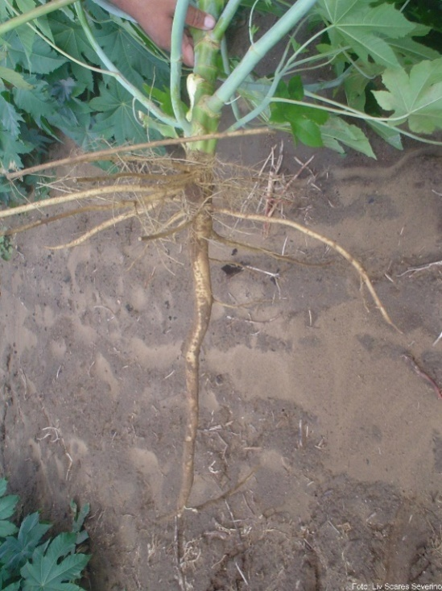
Deep soils, with good drainage, good texture, and well balanced in terms of nutritional aspects, favor the development of the castor plant. The root system of castor plant has the capacity to explore deep layers of the soil, which are not normally reached by most annual crops, such as soybeans, corn, and beans. This ability to take up water from deep layers is very important in castor’s ability to tolerate drought.
Castor is demanding in fertility, and the highest seed yields are obtained when the crop is grown in soils with medium to high fertility. The crop prefers soils with pH between 5 and 6.5,but can produce in soils with pH up to 8.0. Castor is not able to achieve satisfactory productivity in soils with low fertility or high acidity or salinity, even if there is good water availability.
Castor is very sensitive to water-logging. About three days of water-logging can cause death of the plants or permanent damage that reduces the seed yield. Soils with high salinity are not recommended, as the presence of a high concentration of salts can impair plant growth. The cultivation of castor in improper soilsand inadequate nutrition can result in plants with low leaf area indices thus exposing the soil to degradation orerosion due to rain and wind. In this way castor crop cultivation can be detrimental to the soil health of a region.
In addition to water-logging, castor is also very sensitive to soil compaction and is even more sensitive to aluminumtoxicity, high salinity and low soil fertility. These conditions limit the plant’s root growth and its ability to reach lower depths of the soil which result in greatly reducedseed productivity.
Soil preparation is also important to reduce weed infestation and aerate the soil, ensuring better growth of roots and increased water infiltration. Before sowing castor seeds, the land must be cleared of weeds and residues from previous crops. It is very important to keep the crop free of weeds for the first 60 days because this is the critical stage for optimizing seed yield.
Soil preparation on flat or gentle sloping lands should be done with a deep plow of up to 30 cm, preferably with a moldboard plow or disc plow. All tillage operations must be done with the soil slightly moist. Although the plowing of the soil helps the development of the plant, on the other hand, it damages the soil, destroying aggregation, pulverizing the particles, and altering its structure. For this reason, the soil should be turned over as little as necessary to control weeds, improve drainage and promote root growth. On hilly terrains it is recommended to use individual basins by applying the reverse slope method as shown in the diagram below.

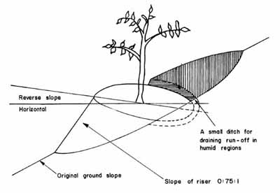
Fig. 2: Diagram showing individual basin (Source: Food and Agricultural Organisation (FAO))

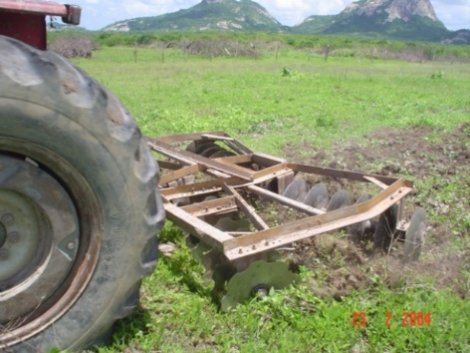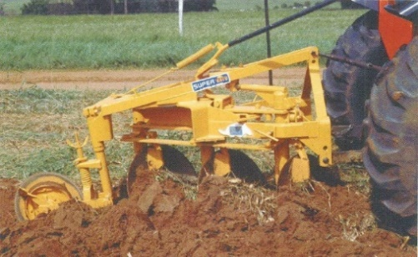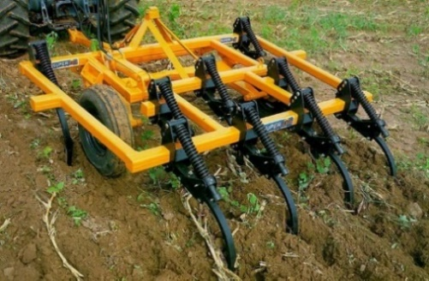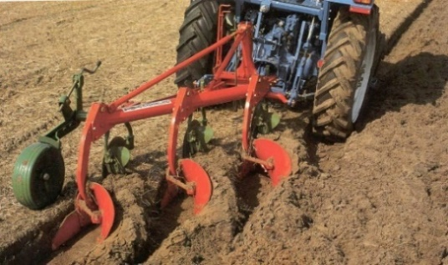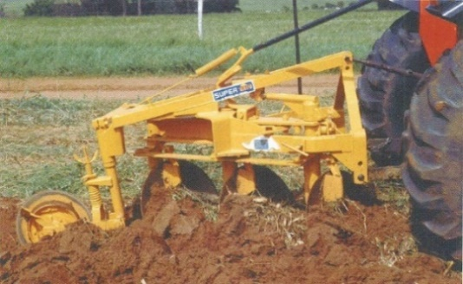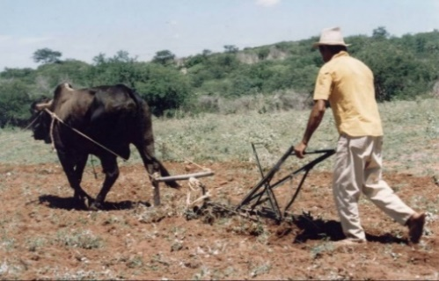

Harrow
Disc Harrow

Disc Harrow
Mold board plough

Disc Harrow
Oxen drawn plough
Fig 3. Examples of farm implements used for land preparation
The pHof acidic soilscan be corrected with limestone and gypsum as this helps to mobilize nutrients in the area around the castor root system. This also promotes the development of the roots as well as improves soil structure. It also aids in reducing erosion. In fertile soil, biomass production is higher, which favors the accumulation of organic matter, making more nutrients available and also provides better protection against erosion by rain and wind.

4. Nutrition or Fertilization

Castor is drought tolerant but not tolerant to low soil fertility and these factors are often confused.Plants grown in acidic soils often show stunted growth, the edges of the lower leaves become whitish and, in some genotypes, there is an increase in anthocyanin production, making the plant reddish. Deficiency of N, P, K, Ca, Mg and S commonly result in strongly decreased growth in the castor plant.
Low pH or soil acidity correctionshould be performed at least 90 days before the date of planting, for optimum castor yield potential. The use of limestone is mandatory to correct the pH of the topsoil, to reach a saturation with exchangeable bases (Ca, Mg, and K) of 60% of CTC at pH 7.0. To increase the tolerance to drought in acidic soil, it is essential to correct the pH in deeper layers by applying gypsum (CaSO₄.2H₂O) at the rate of 50 kg for each 1% of soil clay. This correction will allow root growth at deeper layers where water is more available.
The correct recommendation of NPK fertilization and micronutrients for castor cultivation will depend on the interpretation of soil analysis results. It is recommended to fertilize at planting with the required amount of phosphorus and a portion (up to 1/3) of the nitrogen requiredequally proportioned to each hole. This fertilizer should be placed at the bottom of the hole and covered with soil so that it is 5 cm away from the seed or plantlet to avoid salinity problems.Fertilization with Potassium and the rest of the nitrogen (2/3) should be done as a side dressing, 40 days after planting. Generally, 30 to 75 kg/ha of N, 40 to 80 kg/ha of P₂O₅ and 20 to 40 kg/ha of K₂O are used.
Generally, Potassium (K) tends to reduce growth less than Nitrogen(N) and Phosphorus(P). However, lack of K causes interveinal chlorosis in the lower leaves, starting generally in the upper lobes of the leaves. In contrast, Magnesium (Mg) deficiencyalso causes interveinal chlorosis in the lower leaves in addition to loss of the general colour of the leaf with greener edges and subsequent arching of the leaves on the stem with wilting, and/or complete drying and detachment. Sulfur (S) deficiency causes chlorosis (reduced green pigment in leaves) and deformation of the pointer (youngest) leaf, which takes the shape of a cup and becomes yellowish; followed by the neighbouring leaves turning their edges downward, looking like a clown's hat.If not corrected, the yellowing progresses from top to bottom taking over the entire plant.
The height of the castor plant is influenced by the amount of phosphorus (P). The number of leaves, leaf area, stem diameter, number of capsules, seeds and seed weight showed significant positive response with higher doses of nitrogen fertilizer. However, balanced nutrition is required as N deficiencies severely affect plant performance as shown in Tables 1 and 2.

Table 1. Summary and illustration of nutrient deficiencies in castor bean crop.
Nutrient | Deficiency Symptomatology | Visual appearance
N  Nitrogen | Strong reduction in initial growth or even its paralysis; generalized chlorosis in older leaves, with or without islands of dark green pigments on the leaf; strong defoliation and ascending chlorosis to the pointer leaf. Death of the plant or strong reduction in productivity. These symptoms may be less pronounced at the seedling stage or in early development with the typical yellowing being absent and failure to diagnose nitrogen deficiency. | 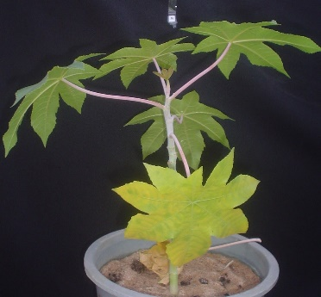
P  Phosphorus | Plant shows moderate reduction in growth initially; leaves turn dark green in colour that quickly develops yellow-tan chlorotic patches, with greenish pigments distributed reasonably homogeneously over the leaf surface.  Necrosis ensues at the borders with blackening of the previously greenish pits. Yellowing and/or leaf fall follows. There may or may not be sparse spots on the leaf blade, which may coalesce and take over the entire leaf. If deficiency continues severe reduction in productivity and eventual death of the plant. | 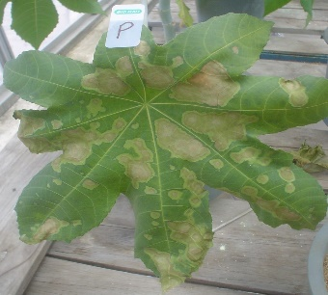
K  Potassium | Moderate reduction in initial growth. Interveinal chlorosis in older leaves, which quickly progresses to generalized chlorosis, with leaf closure, drying, necrosis and fall. The symptoms continue to progress from the blower leaves up to the pointer leaf. There is great defoliation and a sharp drop in productivity. | 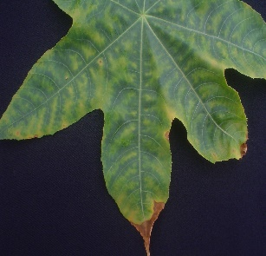
Ca  Calcium | When the new leaf is beginning its expansion, small black dots are visible at the edges of the leaf blade. As the leaf blade expands, those small dots impair the regular extension of the veins, and the leaf does not grow to the regular shape (with lobules), but becomes circular. It is very common to have a transitory calcium deficiency at field conditions in a few isolated plants, especially when the plant is growing fast. In general, this transitory deficiency does not require any intervention, and it disappears in the new leaves without any intervention being required. | 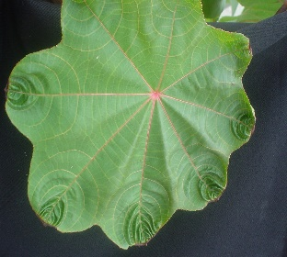  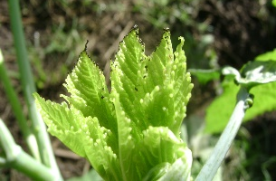
Mg  Magnesium | General stunting and defoliation. Interveinal chlorosis in older leaves, which persistently advance towards the leaves at the center of the plant. Eventually, leaves turn yellow with greenish spots in the interveinal regions. Chlorosis can progress and take over the entire leaf, which droops overthe stem, wilts, dries and eventually falls off. | 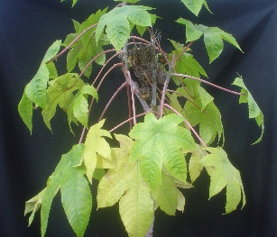
S  Sulfur | Growth reduction. New leaves acquire a lime green color that soon expands to the larger neighboring leaves. The young leaves turn into a cup shape and the chlorosis increases; the neighboring leaves have their edges turned down in a typical clown hat shape; the leaves may have necrosis (death of plant tissues) at the tip of the lobes, which evolve over the entire margin, which can cause tearing. Lime green chlorosis advances from top to bottom of the plant, yellowing the entire plant. There is abundant overgrowth with the plant appearing bushy. The inflorescence blackens and dies. | 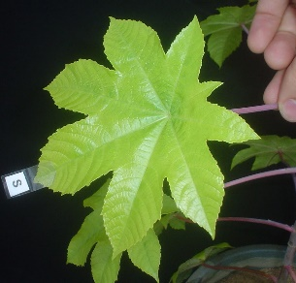
B  Boron | In the acute phase, growth is reduced. The newer leaves thicken and become rough to the touch and brittle; the petiole breaks easily. The lobes fail to expand to the regular form. The terminal bud dies. The older leaves senesce with minor water stress. In chronic deficiency, the number of fruits in a bunch is severely reduced. This is due to failure in fertilization of the flowers and so in the formation and maintenance of the fruits in the bunch. When bunches are formed they may become twisted.  Other symptoms under acute deficiency, include the leaves apices(tip of leaves) crinkle, harden, and are deformed with few lobes developing. There is necrosis at the apices of the lobes and/or at the edges of the leaf and/or at the base of the leaves, which eventually drops. Internodes are shortenedresulting in crowding of the leaves or bushy appearance. Flowering and fruiting are severely impaired. | 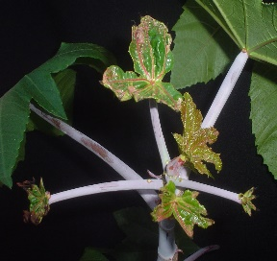
Mn  Manganese | The leaves on the top of the plant become chlorotic, and the chlorosis progresses to the interveinal region of the leaf leaving a thick network of ribs on a yellow-green background.
Mo  Molybdenum | Light chlorosis occurs from the bottom up in the plant, which evolves very slowly. The older leaves have generalized chlorosis, like the deficiency of N. Then, they arch or droop over the stem, wilt and fall.
Source: Ferreira et al. (2008).

Table 2. Analytical key to identify nutritional problems in castor.
Symptoms | Probable cause
Generalized chlorosis in older leaves | -N, -Mo, -K, -Mg
Growth too slow or stalled | -N, -P or -K
Generalized chlorosis in older leaves, with rapid and sharp leaf fall and absence of interveinal chlorosis typical in other newer leaves. Nitrogen deficiency promotes gradual yellowing of the lower leaves progressing from the bottom up, leaves drop,defoliating the plant,which significantly reduces its productivity. Too much nitrogen results in proliferous leaf growth at the expense of flower formation, fruit set and root growth. | -N
Generalized chlorosis in older leaves, with the presence of interveinal chlorosis, advancing from the edges towards the center of the leaf. Near the edge of the leaf, the chlorosis becomes widespread. | -K
Oily leaf spots on older leaves caused during severe emergence failure; intense loss of older leaves and watery stains on new ones. | + N or K
Phosphorus deficiency leads to the slow growth of plants with intense dark green leaves, which becomes tanned, dotted with dark green areas and blackened borders. Leaves fall, defoliating and preventing crop production. | -P
Generalized chlorosis in older leaves with the presence of typical and persistent interveinal chlorosis throughout the leaf. | -Mg
Generalized chlorosis in older leaves that advances very slowly up the plant, with little defoliation, slight loss of green colour from bottom to the top of the plant and absence of leaves with interveinal chlorosis. | -Mo
Typical clown hat leaves, with watery stains between the lobes.Calcium deficit hardly occurs in the field; however, when it does occur it weakens the roots and predisposes the plant to the attack of soil fungi, especially fusarium. | - Ca
Typical lime-green chlorosis in the youngest leaf that advances very quickly to the neighboring leaves, which can take on the appearance of a clown hat with downturned edges. The newer leaf looks like a cup. Plants show stunting. | - S
Younger leaves with undifferentiated lobes, thick and rough, with death of apical bud or visible overgrowth. Adult plants whose leaves have reduced capacity totolerate wilting underhigher temperatures, cannot rehydrate and will dry with very brittle petioles. Very small, underdeveloped fruit bunches, with visible failure of fertilized flowers; intense drop of new fruits; twisted fruit bunches. | -B
Younger leaves with marked chlorosis with veins becoming dark green and pronounced,forming a typical fine network on a yellowish background. | -Fe
Younger leaves with medium to light chlorosis, forming a thick net on a yellowish-green background. | - Mn
Newly expanded leaf with over developed lobe, in the form of fingers; slight chlorosis on the leaf, with or without yellowish punctuations in the interveinal region. | - Zn
Reduced growth with no apparent nutritional cause | Soil compaction
Root dieback, collar swollen and appearance of adventitious root with wilting of the plant | Waterlogging
Plant stunted with nutrient deficiency symptoms of various nutrients in the field | Excessive acidity or soil pH too low
Small plant with short thick fibrous roots | + Al

5. Planting
Castor must be planted in full sun as it does not tolerate shade.As such avoid shading of trees. During the early stages of development, the soil is exposed to erosion as the castor plants are too small to protect the soil from the impact of raindrops. For this reason, proper soil conservation techniques is recommended in areas where the slope is greater than 12%.The soil must be fertile and/or properly corrected for acidity, have sufficient depth for root peneration and with good drainage. If cultivatingon slopes can’t be avoided, soil preparation and sowing operations must be carried out following the direction of the land level curves/contours.
Seed treatment before planting is highly recommended to minimize the impact of soil borne pathogens (such as Pythium, Fusarium, Rhizoctonia, Penicillium, and Colletotrichum) and insects that may damage the seedling in the first week of development. The active ingredients and dosage must follow the recommendations for approved fungicides and insecticides used for seeds in Jamaica. Seed treatment for soil diseases and insect pests are obligatory especially where there are previous records of insect and pathogen damage to castor seedlings or in other crops.

Ideal average temperatures in the range of 20 ºC to 35 ºC are the most suitable for castor. However, castor is highly adaptable which expands its temperature range. Dry periods are best for seed production/processing in castor to avoid gray mold. However, castor has higher productivity where there is adequate water available during the growth phase. Economically viable castor production can only be achieved if the crop receives at least 500mm of water between sprouting and flowering. Lack of water during this period will significantly reduce yields.

Based on the document “Introducing the IRI high spatial resolution 10-year rainfall dataset for Jamaica” the best planting period for castor is in the months of February and March and possible second cycle during the months of September and October, where some parishes reach up to 10 mm/day of rainfall.
Figure 4 showing best planting times over 2018 -2019 and optimum castor seed harvest

Rule of thumb is to plant at a time in the when the seedlings will receive adequate water (~500 mm) by fruit set. This should be followed by a relatively dry period during which the capsules mature, and the crop can be harvested. In this way losses from gray mold can be minimized. Exceptions occur only in specific situations, like when heavy rains are frequent in the beginning of the rainy season or when the harvesting time falls in a rainy time. There is a negative correlation between planting time and seed yield, meaning that delayed planting is one of the factors reducing castor seed productivity. It was estimated that for each month that the planting was delayed, the castor seed yield was reduced by 60 pounds per acre.

In environments with rainfall above 700 mm during sowing and flowering, castor can reach productivity in excess of 1500 kg /ha. Sowing at the beginning of the recommended period for the region is critical in rainfed castor production so that water is available in the soil. Planting outside of the recommended period results in low water availability during pre-flowering stage which can severely compromise productivity.

Between flowering and fruit ripening, low relative humidity is recommended to avoid the development of diseases on the leaves and gray mold on developing capsules which develops with high humidity, surface wetness, and mild temperature. The ideal relative humidity for castor fruit development is in the range of 30 to 60% of air moisture. These conditions can easily be achieved in the south-western half of Jamaica, where most of the parishes that are producing castor lie, have a sem-iarid climate and receive less than 760 mm of rainfall annually.

The agro-ecological analyses of castor seed production in different parishes and soil type data from 2018 to 2019 is shown in Tables 3 and 4. The dataset was collected by the JBU from farmers in castor production of that period. As such the information is only presented as a guide and not meant to be in any way prescriptive. However, the higher performance in clay soils is typical for castor as clay retains more moisture and nutrients which are available to the plant during the critical pre-flowering stage. The data also demonstrates that castor yields can be significantly improved in Jamaica by planting at appropriate times and using best production practices in Jamaica.
Table 3: Productivity of castor seed according to the Parish and calculated considering the total production and the total planted area.
Parish | Total production of castor (lb) | Total cultivated area (ac) | Yield  (lb/ac)
Clarendon | 1,779.0 | 9.4 | 189.3
Manchester | 4,477.5 | 8.5 | 526.8
Portland | 890.0 | 3.0 | 296.7
St. Andrew | 285.5 | 5.0 | 57.0
St. Ann | 11,146.5 | 16.3 | 685.8
St. Catherine | 4,108.0 | 14.2 | 289.1
St. Elizabeth | 6,532.3 | 37.5 | 174.4
St. James | 52.0 | 1.1 | 47.6
St. Mary | 411.0 | 3.0 | 137.0
St. Thomas | 344.0 | 0.3 | 1,376.0
Trelawny | 10,160.5 | 12.4 | 819.4
JAMAICA | 40,186.3 | 110.6 | 363.5

Table 4: Productivity of castor seed according to the soil texture
Soil texture | Count | Average castor yield (lb/ac) | C.V. (%)
Clay | 11 | 1,304.5 | 94.2
Clay loam | 14 | 315.7 | 104.6
Loam | 3 | 429.9 | 65.2
Sandy loam | 5 | 315.0 | 70.9
Stony clay | 3 | 284.2 | 97.1
Stony loam | 3 | 55.0 | 61.8

6. Seed Selection

Castor seed used for planting must be produced to maintain genetic purity. The most important measure to reduce crop seed loss in the field is to plant high quality seed. All the wild castor plants are dehiscent. Do not use seeds saved from previous production cycles, nor those of wild castor plants found in land landfills and abandoned areas as they do not have the genetic purity to achieve good productivity. Seed that is produced without proper care will eventually be contaminated with wild castor varieties and year after year becomes very dehiscent. When a contaminated variety is planted, the farmers are required to harvest several times when the fruits are still very immature. Any delays in harvesting time results in the fruits opening and the seeds being scattered, falling to the ground. In addition, during drying the fruits will open and seeds will be lost, further reducing farmers’ income from the crop.
Farmers should purchase the seeds from reliable/certified seed producers and choose a cultivar that is appropriate to the planting region. For Jamaica, one of the most recommended cultivars to use is BRS Energia. You will find BSR Energia Data Sheet in Annex 1.

Alternatively, seed for planting can be produced in isolated fields (no castor plants of any type within a 1-mile radius) and taking care to maintain purity of the line. Several isolated fields need to be planted every year. A small field needs to be maintained with the seed in the highest purity level or breeder's seed in order to have a supply of pure seed available every year to produce the commercial seed. In the breeder’s field, a trained person must know the descriptors of the variety and eliminate all plants that are not typical of that genotype. Plants are bagged and the seeds produced from the Breeder’s seed field are used to establish one or more isolated fields to produce the seed that will be delivered to farmers or the commercial seed. The commercial seed fields also need to be inspected to eliminate atypical plants before fruit set. Each batch of seed (breeder’s and commercial) needs to be processed (dehulled and cleaned) with care to prevent contamination. If possible, it should be done using separate equipment to reduce the risk of contamination. It is also necessary to comply with the local regulations for seed production and trade.

7. Thinning and seed/seedling spacing
Thinning is necessary when planting by hand or with manual equipment. Manual planting should be done by placing two seeds per hole with a depth around 5 cm. If planting is done very close to the surface, the soil can dry out quickly after rain especially in sandy soils making conditions unsuitable for germination. If planting is done too deep, especially in clay soils, it is likely that many plants will not push through the heavy soil and reach the surface
After emergence, only one plant per hole must be allowed to grow to avoid competition for light, water and nutrients. If two plants are allowed to grow, they will not produce double yield, but instead the two plants will produce less seed than one plant growing alone.

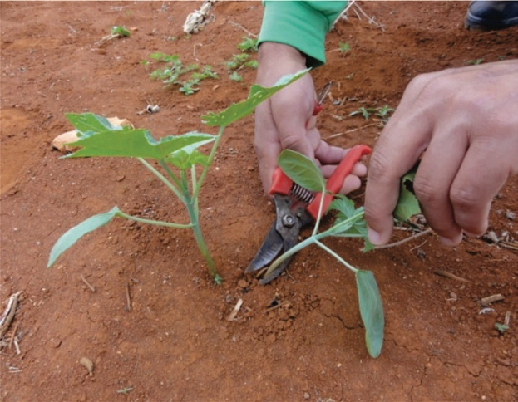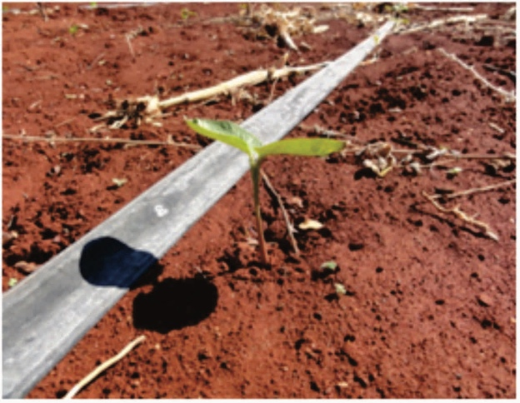
After
Before
Figure 5 showing Thinning, how to eliminate unwanted plant without damaging roots of the plant that remains.
Thinning should be carried out 15 days after planting or when the seedling reaches 10-12cm in height. Perform the thinning when the soil is moist and use pruning shears to cut the plant to be eliminated by pulling to the side. Avoid damage to the root of the plant that will remain.
Seed spacing and plant densityare dependent on environmental factors, the size of the castor variety plant used, the fertility of the soil, the option for the use in intercropping, and the need for animals or machines to control weeds.
For medium-sized (4ft to 6ft tall) cultivars, a spacing between 2m and 3m between rows is recommended, and one meter between plants within the planting line. A narrower spacing may provide greater productivity if there is good water availability. This spacing also allows intercropping with small food crops such as common bean or peanut.
When small and dwarf (up to 4ft tall) cultivars are used, the definition of the plant population is more complex. These genotypes show great variation in growth habits and in response to environmental conditions. High population density induces excessive growth in height and lodging of plants. Low densities facilitate weed infestation, decrease precocity, favor the formation of long branches and reduce crop productivity. Crops with small size cultivars are more suitable for mechanized harvest. The spacing between plants in the row varies from 0.30m to 1.0m, depending on the cultivar. For mechanized planting, cultivars that support high plant populations are more suitable.
In mechanized sowing, vacuum sowing machines or horizontal discs adapted to the size of the seed can be used, the ideal being to distribute three seeds per linear meter, with a spacing between lines varying from 80 cm to 1 m.
BRS Energia can be planted at 1 m between rows and from 1 m to 0.5m between plants within a row.
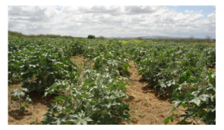
Figure 6 showing field of BRS Energia.

8. Castor Growth Stages

The castor crop cycle is annual and very occasionally biennial in tropical regions. The annual cultivars have an average crop cycle of 150 days with the early cultivars between 120 to 130 days, which is more suitable for mechanical harvesting.
There are 12 stages in the castor crop cycle namely:
- (Stage1- E) germination;
- (Stage2-V10) formation of the opposite true leaves,
- (Stage 3-V20) segmentation of the raceme axis occurs and ends with the formation of the fifth or sixth true leaf,
- (Stage 4-P30) differentiation of the primary meristem and formation of the first raceme or panicle, (Stage 5) differentiation of the floral part occurs
- (Stage 6) formation of pollen and embryonic sac
- (Stage 7-P40) differentiation and growth of secondary raceme/panicle
- (Stage 8) buttoning phase or flower emergence
- (Stage 9) flowering and pollination
- (Stage 10-P50) formation of fruits and seeds
- (Stage 11-M60) deposition of oil,
- (Stage 12-D70) maturation of the fruits.

The timing of the different phases is dependent on variety and highly affected by growing conditions. For example, with BRS Energia, flowering typically begins about 30 days after sowing and the plant begins to set fruit. However, flowering will occur later in regions with low temperature and low sun light.
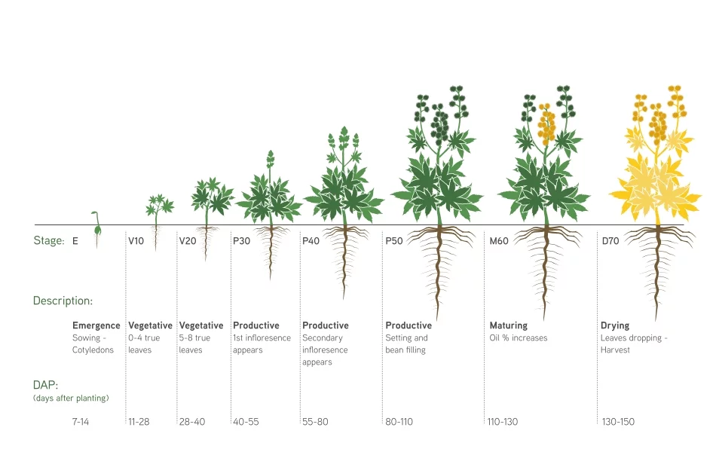
Figure 7 showing visible stages in the Castor crop cycle for a typical manual planted variety

9. Harvesting

Harvesting shattering varieties of castor is labor-intensive and costly because it requires up to 6 harvests in the crop cycle.A shattering variety is one in which the fruits open at maturity scattering the seeds. There are varieties that are partially shattering, in which the bunches allow some time for harvesting after they reach maturity, butwill shatter scattering the seeds if they are not harvested on time. These varieties tend to be heavily influenced by sunny days and dry air which cause the fruits to open. In a non-shattering variety, the fruits do not open before harvest. For this reason, selection and planting of non-shattering or true castor varieties is preferred to have only one harvesting of the entire crop.

BRS Energia is a non-shattering variety that can be harvested in a single pass when all the bunches of the plant reach physiological maturity. At this stage of development, the seed has maximum vigor, oil content and germinative power.

9.1 When to harvest

Shattering varieties: harvest when 70% of the raceme fruits are dry andcomplete drying on a terrace or in mechanical dryers. Harvesting when most fruits are still green decreases the oil content.

Non-shattering varieties: wait for the total ripening of the crop before proceeding to a single harvest.In case of using BRS Energia, manual harvesting must be carried out when all the fruits of the bunch are dry, removing the fruits from the stalk before putting them in the drying place to facilitate the processing. The drying period depends on the climatic conditions after the harvest – being shorter in hot and dry regions and longer in milder and humid regions. For mechanized harvesting, the plant must be defoliated and all bunches of the plant must be completely dry.
An example of the timing of the main activities for a 6-month castor variety in Jamaica is shown in the table below:

Cropping Cycle 1: February – August

Month | Activity
February-March | Planting time:  - Land preparation (Clearing, soil tillage and digging of holes on flat lands. Digging of holes or individual basins only on sloping lands to prevent soil erosion). Soil preparation on flat or gentle sloping lands should be done with a deep plow of up to 30 cm, preferably with a moldboard plow or disc plow.On hilly terrains (greater than 12% slope), it is recommended to use individual basins for each plant using the reverse slope method.  - Application of pre-emergent weedicide (optional)  - NB: Soil tests should be done and correction of pH(adding limestone or gypsum) should be done at least 3 months before planting.  - Fertilizer application must be based on recommendations from soil analysis. This fertilizer should be placed at the bottom of the hole and covered with soil so that it is 5 cm away from the seed for plantlet to avoid salinity problems.  - Planting of seeds or seedlings - For medium-sized (4ft to 6ft tall) cultivars, a spacing between 2m and 3m between rows is recommended, and one meter between plants within the planting line.  - Resupply of seedlings or thinning as the situation requires - Thinning should be carried out 15 days after planting or when the seedling reaches 10-12cm in height  - Seed treatment before planting is highly recommended to minimize the impact of soil borne pathogens (such as Pythium, Fusarium, Rhizoctonia, Penicillium, and Colletotrichum) and insects that may damage the seedling in the first week of development.USE CHEMICALS AS DIRECTED BY MANUFACTURER.
March-June | Crop maintenance:  - Fertilization with Potassium and the rest of the nitrogen (2/3) should be done as a side dressing, 40 days after planting. Generally, 30 to 75 kg/ha of N, 40 to 80 kg/ha of P2O5 and 20 to 40 kg/ha of K2O are used.  - Weed management – Care should be taken not to damage plant structures such as roots, stems and leaves.  - Scouting to identify the presence of pests and diseases  - Pests and disease control (Use chemicals that are recommended by the JBU. Farmers must handle and apply chemicals as directed on the package by the manufacturer.  - Irrigate plants as needed preferably late evening or early morning to reduce moisture loss due to evaporation. Take rainfall into consideration and adjust watering accordingly.  - Identify appropriate area for storing harvested seeds  - Prepare containers for harvesting and transporting seeds.
May-August | Harvesting, drying and seed cleaning:  - Look for the presentation/appearance of the first fruits  - Monitoring the colour change of the fruiting body/raceme as it goes from green to brown  - Harvest when 70% of the raceme fruits are dry or complete drying on a terrace or in mechanical dryers. Harvesting when most fruits are still green decreases the oil content. Store harvested seeds in a dry well ventilated area  - Ensure seeds are dried properly on open catchments, tarpaulin or your preferred drying method.  - Clean/polish dried seeds and package for collection as directed by the JBU

Cropping Cycle 2: September to February

Month | Activity
September - October | Planting time:  - Land preparation (Clearing, soil tillage and digging of holes flat lands. Digging of holes/individual basins only on sloping lands to prevent soil erosion). Soil preparation on flat or gentle sloping lands should be done with a deep plow of up to 30 cm, preferably with a moldboard plow or disc plow.On hilly terrains (greater than 12% slope), it is recommended to use individual basins for each plant using the reverse slope method.  - Application of pre-emergent weedicide (optional)  - NB: Soil tests should be done and correction of pH(adding limestone or gypsum) should be done at least 3 months before planting  - Fertilizer application must be based on recommendations from soil analysis. This fertilizer should be placed at the bottom of the hole and covered with soil so that it is 5 cm away from the seed for plantlet to avoid salinity problems.  - Planting of seeds or seedlings - For medium-sized (4ft to 6ft tall) cultivars, a spacing between 2m and 3m between rows is recommended, and one meter between plants within the planting line.  - Seed treatment before planting is highly recommended to minimize the impact of soil borne pathogens (such as Pythium, Fusarium, Rhizoctonia, Penicillium, and Colletotrichum) and insects that may damage the seedling in the first week of development. USECHEMICALS AS DIRECTED BY MANUFACTURER.  - NB. Soil tests should be done and correction of pH(adding limestone or gypsum) should be done at least 3 months before planting
October - March | Crop maintenance:  - Fertilization with Potassium and the rest of the nitrogen (2/3) should be done as a side dressing, 40 days after planting. Generally, 30 to 75 kg/ha of N, 40 to 80 kg/ha of P2O5 and 20 to 40 kg/ha of K2O are used.  - Weed management - Care should be taken not to damage plant structures such as roots, stems and leaves.  - Scouting to identify the presence of pests and diseases  - Pests and disease control (Use chemicals that are recommended by the JBU. Farmers must handle and apply chemicals as directed on the package by the manufacturer.  - Irrigate plants as needed preferably late evening or early morning to reduce moisture loss due to evaporation. Take rainfall into consideration and adjust watering accordingly.  - Identify appropriate area for storing harvested seeds, prepare containers for harvesting and transporting seeds.
January - March | Harvesting, drying and seed cleaning:  - Look for the presentation/appearance of the first fruits  - Monitoring the colour change of the fruiting body/raceme as it goes from green to brown  - Harvest when 70% of the raceme fruits are dry or complete drying on a terrace or in mechanical dryers. Harvesting when most fruits are still green decreases the oil content. Store harvested seeds in a dry well ventilated area  - Store harvested seeds in a dry well ventilated area  - Ensure seeds are dried properly on open catchments, tarpaulin or your preferred drying method  - Clean/polish dried seeds and packaged for collection as directed by the JBU

ANNEX

Annex 1: BRS ENERGIA DATA SHEET

BRS Energia is a castor cultivar or variety with an early crop cycle and excellent adaptation to different ecosystems if adequate rainfall occurs during its vegetative development (at least 500 mm).
Crop Cycle: 120 days on average between sowing and harvesting.
Yield: 1,800 kg/ha on average, if technical recommendations are followed and in favorable climatic conditions.
Flowering of the first bunch: At 30 days after germination which may be later in conditions of low temperature and low light.
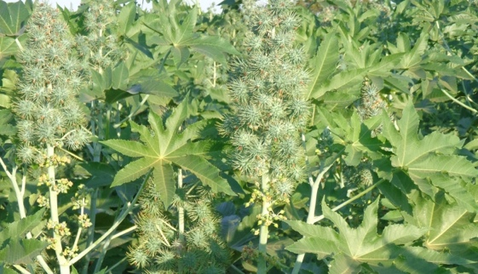
Plant height: 140 cm (4½ ft) on average.
Leaves: green ribbed in the same colour and average size
between 45 cm and 55 cm (18” to 22”)
Stem: green and with wax.
Bunches: Conical in shape with green waxy fruits
Bunch size: Between 40 cm and 80 cm (16” to 32”)
Number of bunches per plant: 2 to 3 bunches in narrow row spacing and up to 8 bunches in wide row spacing
Fruits: Fruits are non-shattering, that is they do not open spontaneously when they ripen and so retains the seeds.
Reaction to diseases: Moderately tolerant to Root rot (Macrophomina phaseolina): moderately susceptible to Fusarium wilt (Fusarium spp.): very susceptible to Gray mold (Botryotinia ricini)
Number of fruits per bunch: 100 fruits per bunch on average if there is no shortage of water during vegetative phase or excess of water during fruit development.
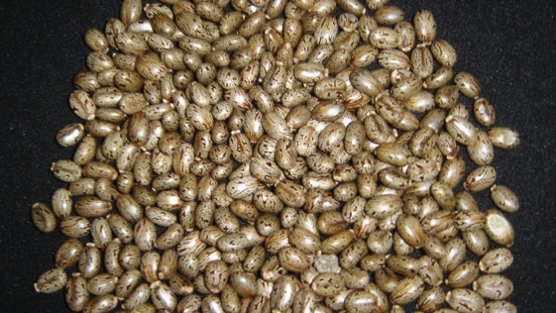
Seed: beige with flecks of brown colors.
Weight of 100 seeds: 35 to 42 g.
Amount of seed for planting: 12 kg/ha
Oil content: 48% on average.

This data is only for one farmer and therefore is not representative for St. Thomas
The lower the % CV the more reliable the data

